# Contents:

1. DockerImages
2. Dockerhub Repository
3. Aws Instance
4. Aws Instance coect
5. Jenkins Installed image
6. Monitor health check

# Docker Image:

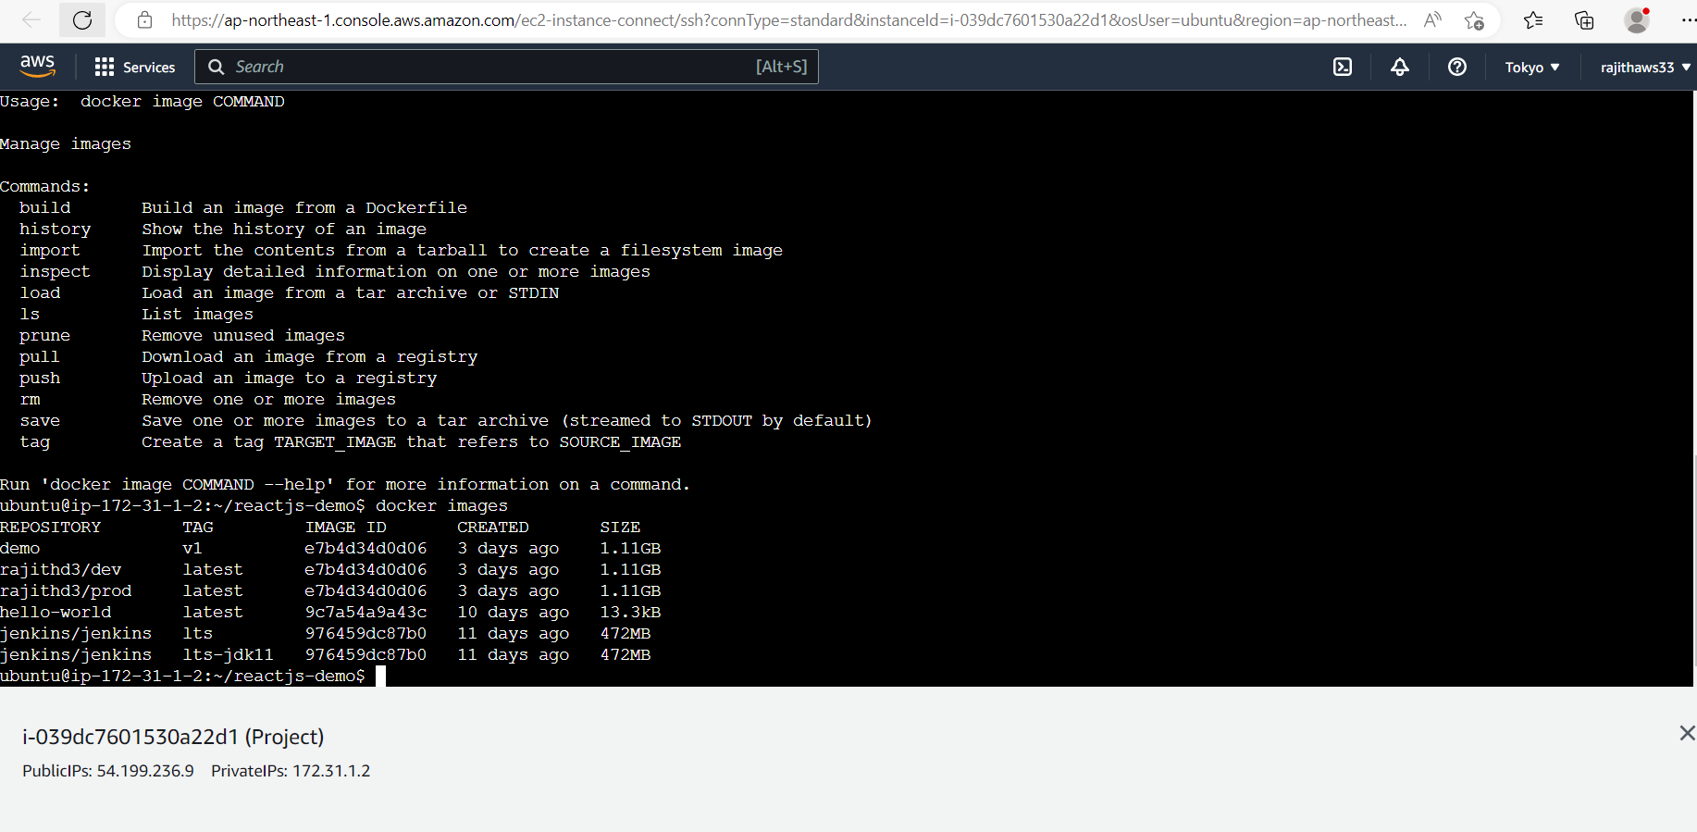

Created demo:v1 image after cloning the app from git repository

# Docker Compose:

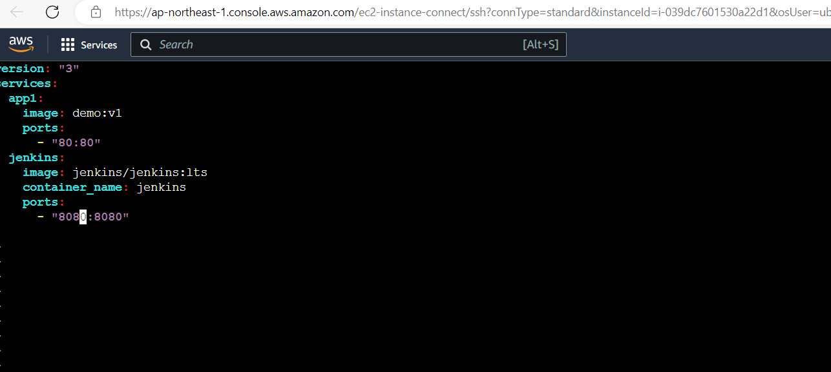

Created a docker compose file to use the above image

# Bash Scripting:

Deploy.sh:

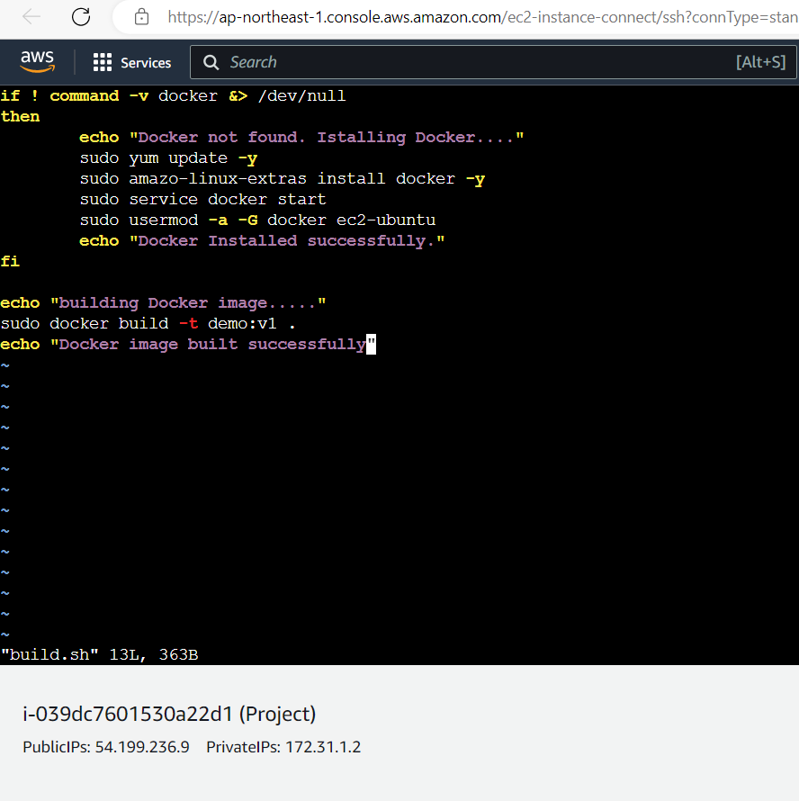

Deploy.sh:

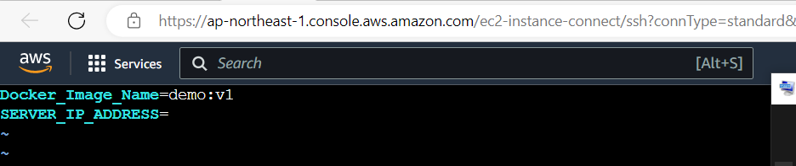

# Version Control:

Created dev branch as per the screenshot:

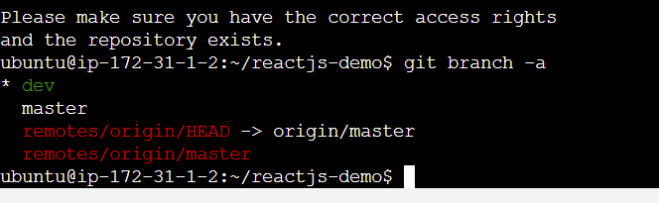

Added .gitignore and .dockerignore files

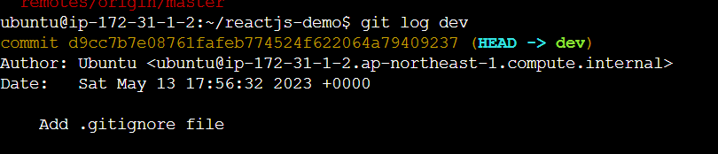

# Docker Hub:

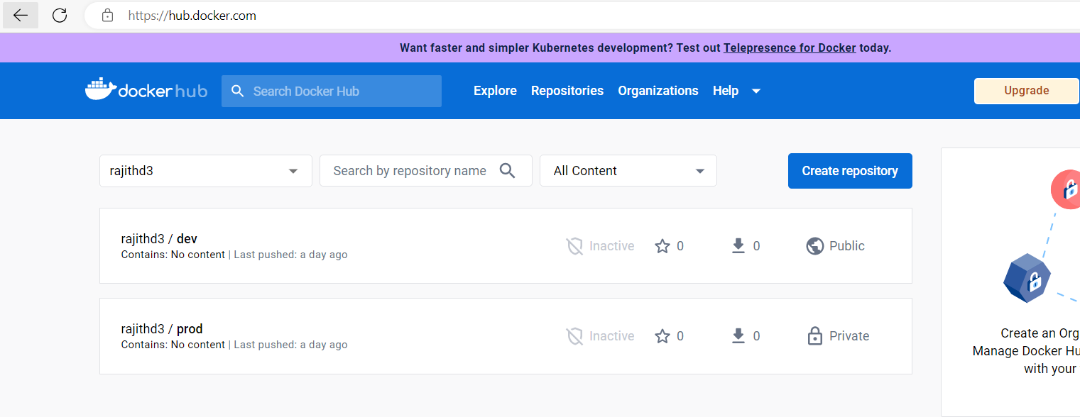

Docker hub repository screenshots:

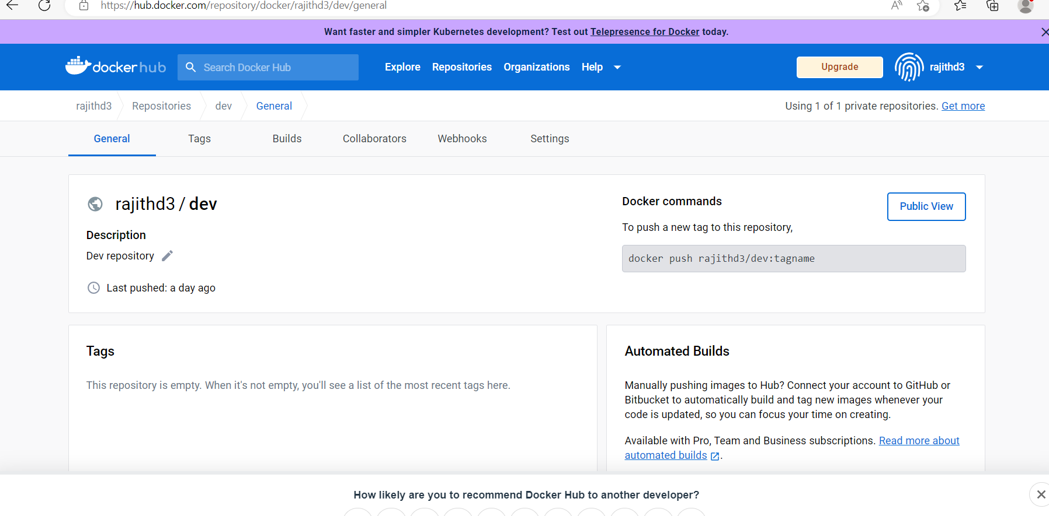

Prod repository private:

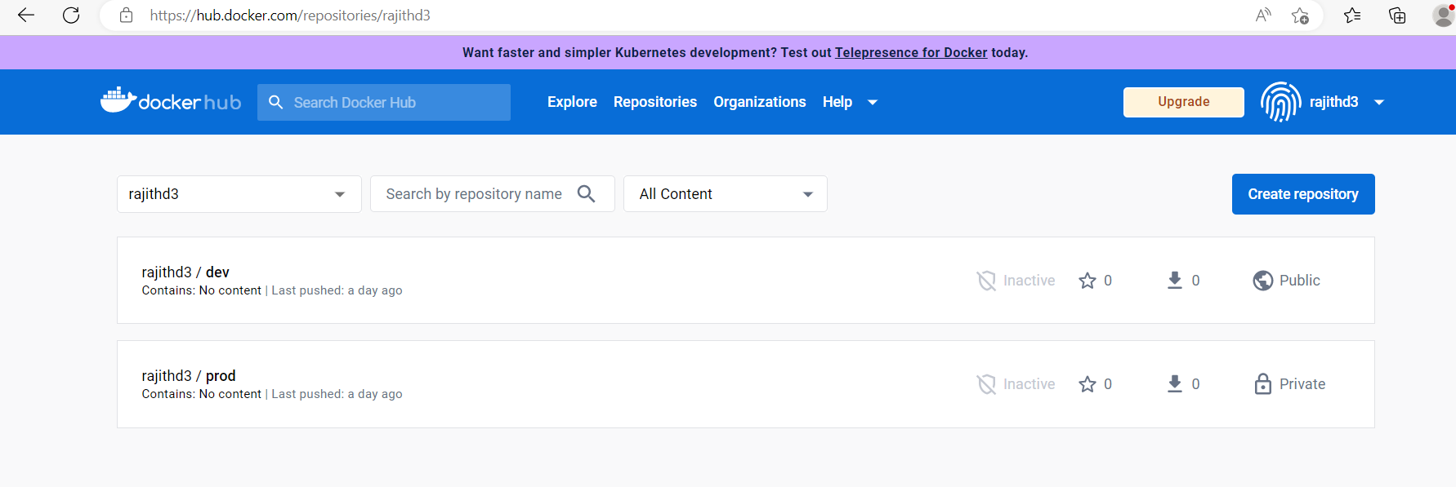

# Jenkins Installation & Cofiguration:

Jenkins installed image s:

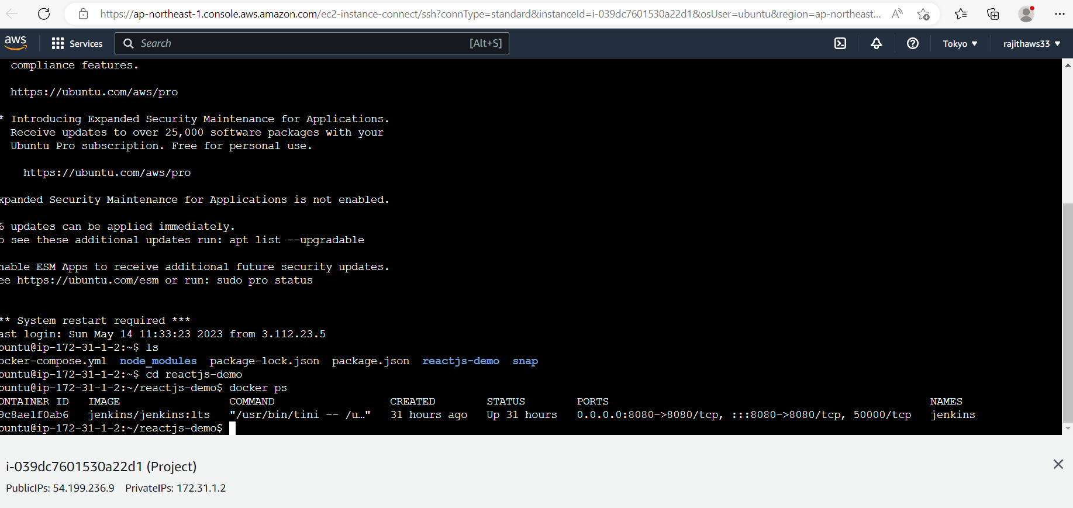

# Aws EC2 instance:

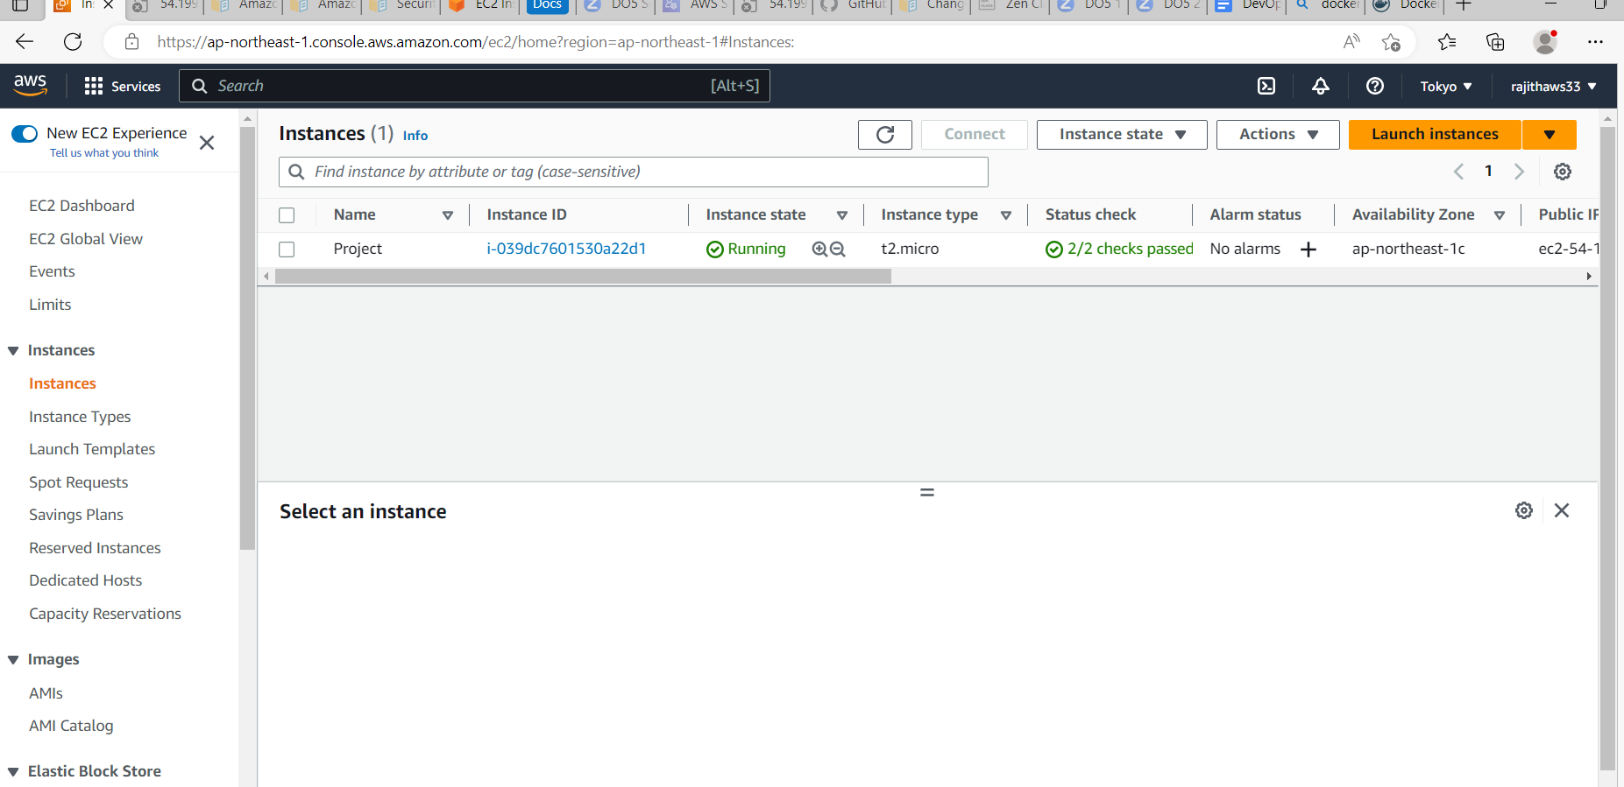

Security groups:

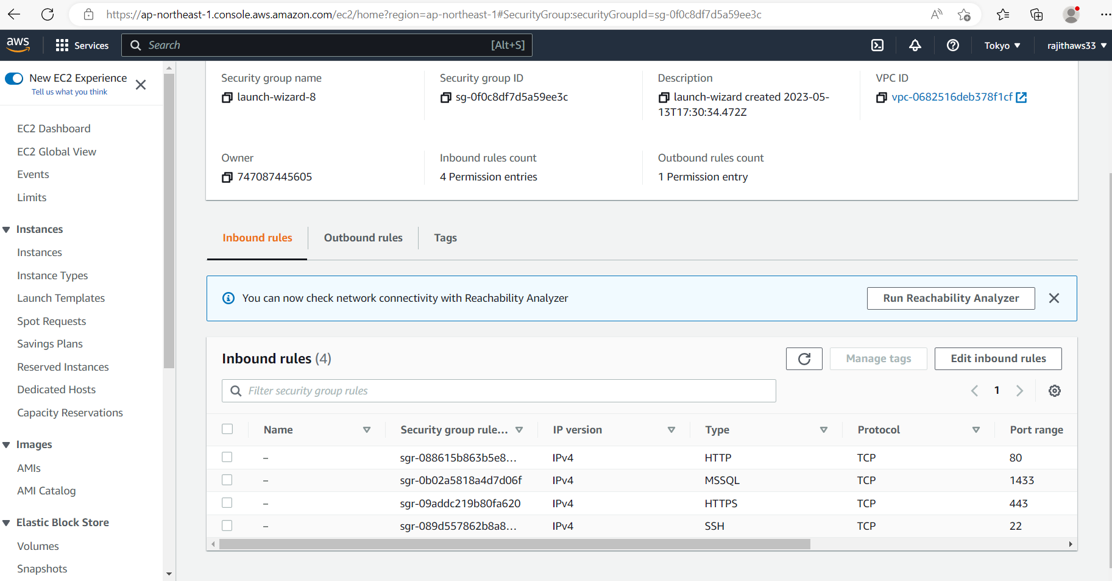

Login to server:

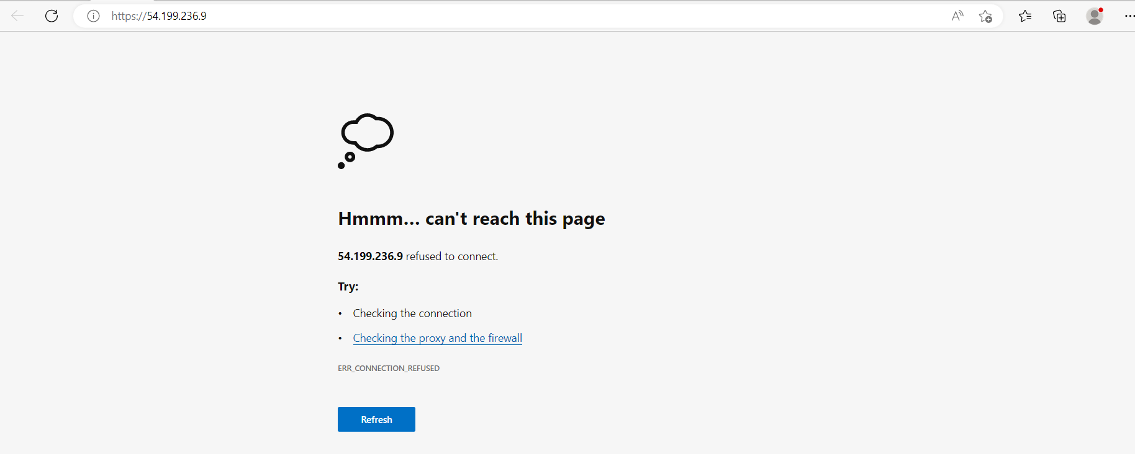

# Monitoring:

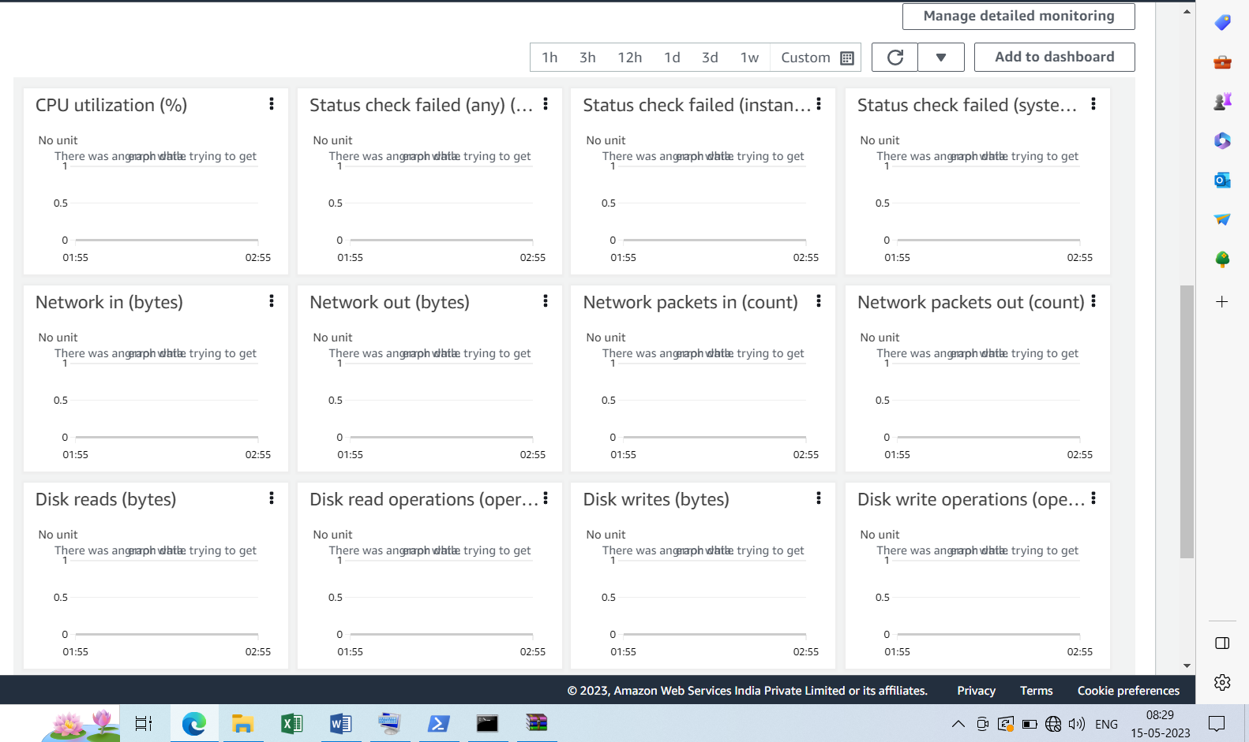

Installed prometheus tool to monitor the health status of the application:

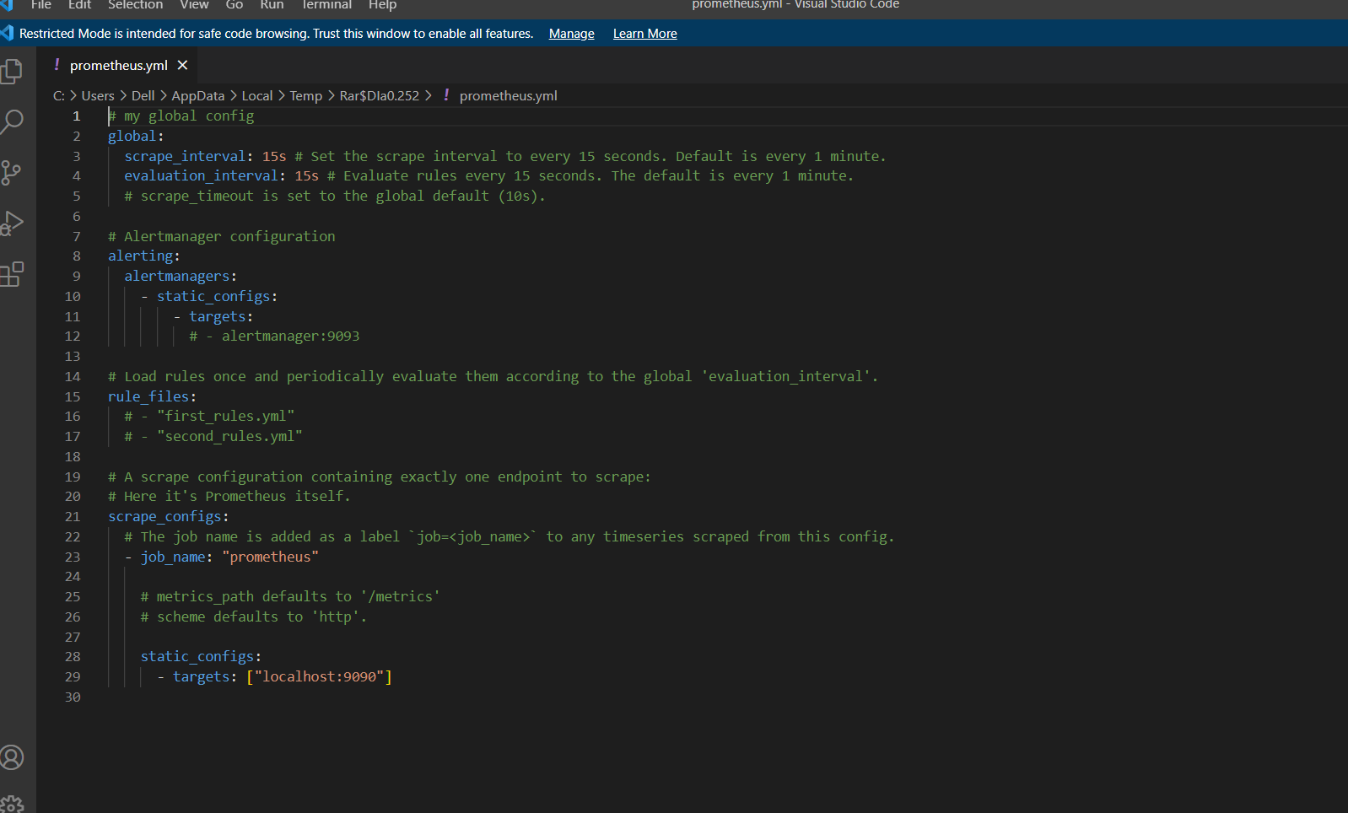

Configuring this file will monitor the health status of the application